embargo UNTIL May 10, 2021, 2PM CENTRAL EUROPEAN TIME

Bluesound Introduces New Generation of the Popular NODE and POWERNODE
The original and award-winning hi-res multi-room streaming favorites get new DAC designs, next generation quad-core processors and intuitive touch panel controls with presets

toronto, Ontario, Canada, May 10, 2021 – Bluesound, makers of the award-winning hi-res wireless multi-room line of audio players, has announced a new generation of its best-selling NODE Wireless Hi-Res Multi-Room Music Streamer and POWERNODE Wireless Hi-Res Multi-Room Streaming Amplifier. The upgrades include new DAC designs, more powerful processors, and touch panel controls with presets and proximity sensors, while the POWERNODE also receives substantially more power. Both feature an easy-to-clean satin finish in either black or white. The NODE will retail for US$549 and the POWERNODE for US$899. Available for pre-order now, they will begin shipping in June 2021.

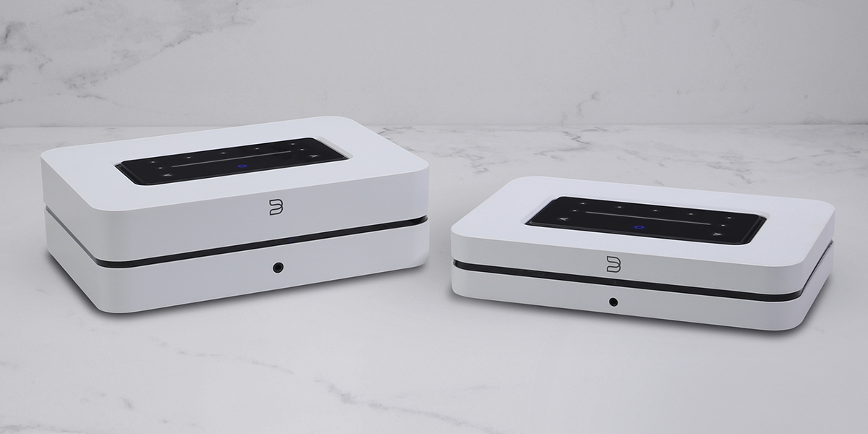

Bluesound POWERNODE Wireless Music Streaming Amplifier and NODE Wireless Music Streamer

the node WIRELESS HI-RES MULTI-ROOM MUSIC STREAMER

WIFI YOUR HIFI

The BLUESOUND NODE unlocks the world of hi-res music streaming and multi-room audio to create a modern addition to existing hi-fi systems or your favorite set of powered speakers. Discover all the music ever recorded with access to hundreds of internet radio stations, dozens of streaming music services, or even your own digital music library, with a few taps of the BluOS Controller app for iOS, Android, Mac or PC computers.

Bluesound NODE Wireless Music Streamer
Inside, the NODE features a new audiophile-grade DAC design with notably improved performance that not only supports 24-bit/192kHz audio processing, but also MQA for studio-quality listening. Powerful, user-friendly software features like tone controls and subwoofer crossover optimization allow you to customize your listening preferences in detail. It is also equipped with an array of digital and analog inputs and outputs for maximum versatility. Bring music into your NODE using Wi-Fi or ethernet, Apple AirPlay 2, aptX HD Bluetooth, or USB Type A connectors, to hear audio content from streaming services, internet radio and your own music library. The NODE now features an HDMI eARC input on the back panel, to keep your setup flexible and future-friendly. Designed to be as comfortable in a two-channel TV system or gaming console as it is in an audiophile’s dedicated listening room, the NODE provides a hi-res experience no matter where it’s used. Listen to your music through your hi-fi system or through wired or wireless headphones, by connecting to the RCA, Toslink optical, aptX HD Bluetooth, 3.5mm jack, Apple devices, or other Bluesound or BluOS enabled players.

Bit-perfect music listening can happen away from your hi-fi system with the NODE as your multi-room hub. The award-winning BluOS platform is the only platform in the world that can support up to 64 players, all streaming in 24-bit hi-res audio. With a growing stable of brands and devices being added to the BluOS platform, the NODE opens up a world of hi-res listening options throughout your home that no other player can.

In addition to using the BluOS Controller app with your smart devices, quick access controls like play/pause, track skipping, and volume are available as touch panel controls, via voice assistants like Apple’s Siri, Amazon Alexa, or Google Voice, by programming your own IR remote or using the optional Bluesound RC1. The intuitive touch panel control with proximity sensor now also features 5 presets. Advanced controls, including tone controls are available in the BluOS Controller app. The NODE can also be integrated into a smart home with full-feature drivers for Lutron, Elan, RTI, Crestron, and other popular home control systems.

NODE KEY FEATURES AND SPECIFICATIONS
- Quad-core 1.8GHz ARM® Cortex™ A53 processor
- 32-bit/384kHz premium DAC design
- HDMI eARC, optical & analog inputs
- Stereo analog, optical, coaxial & USB audio outputs
- AirPlay 2 for integration into Apple ecosystem
- BluOS™ wireless multi-room music capability
- MQA music and hi-res audio streaming
- Voice control with Apple’s Siri, Amazon Alexa and Google Assistant
- Dual-band Wi-Fi + Gigabit ethernet
- Two-way aptX™ HD Bluetooth
- IR remote learning capability, IR input, 12V trigger output
- Wired & wireless headphone output
- Wired & wireless subwoofer output
- Touch controls with presets
- Black or white finish

the powernode WIRELESS MULTI-ROOM MUSIC STREAMING AMPLIFIER

JUST ADD SPEAKERS

The Bluesound POWERNODE is the hi-fi amp reinvented for the streaming age, combining audiophile-grade componentry and multi-room music capabilities to create an intuitive “just add speakers” hi-res sound system for modern music lovers. Source, control, and amplification come packed into the compact and minimalist POWERNODE. Get the most out of your favorite speakers with an award-winning, audiophile-grade amplifier that features 80 watts per channel of zero-distortion power, tested in real-world listening conditions and not just in a lab. A high-grade DAC delivers up to 24-bit/192kHz of hi-res, studio-quality music, including support for FLAC, MQA, and other popular file formats. Access all the music ever recorded through the BluOS Controller app, connecting you to popular streaming services like Spotify, Tidal, Qobuz, SiriusXM, and dozens of others, or from your own music library through Apple AirPlay 2, aptX HD Bluetooth, or even a network-connected drive or USB hard drive.

Bluesound POWERNODE Wireless Music Streaming Amplifier
In one or many rooms, the POWERNODE is a versatile workhorse, placed either freestanding or in a custom installation rack, allowing you to toggle back and forth amongst a number of listening set-ups with a few taps in the BluOS Controller app. Looking for a traditional 2-channel audiophile listening experience? Just add a pair of your favorite speakers. Got a bass-heavy track you love? Add the PULSE SUB+ to your 2-channel set-up to create a capable and musical 2.1 wireless system. Want to kick back with some movies or video games? Bring a pair of PULSE FLEX 2i to the party as rear channel additions to your 2.1 system for a wireless Dolby® surround sound home theater experience. Want to listen to your favorite music in other parts of your home? Sprinkle other BLUESOUND players around your home for a multi-room audio solution.

The POWERNODE is equipped with an array of digital and analog inputs and outputs to give you ultimate connection flexibility. It supports HDMI eARC, dual-band Wi-Fi and Gigabit ethernet, Apple AirPlay 2, aptX HD Bluetooth receiver and transmitter, RCA, Toslink optical, 3.5mm jack, and USB Type A connectors. Bring music into your POWERNODE from dozens of internet radio and streaming services, Bluetooth devices, TV and gaming consoles, network or local hard drives, nearby Apple devices, CD players, and many others. Then send your music into your favorite speakers, other BLUESOUND players or BluOS devices, Bluetooth headphones, wired headphones, Apple AirPlay devices, or other network-connected speakers.

With BluOS built-in, easily create a DIY multi-room hi-res audio system with a few taps of the BluOS Controller app. Additional hands-free controls are available through voice assistants like Siri, Google Voice, or Alexa. For professional smart home installers, full-feature drivers are available for Lutron, Crestron, RTI, Elan, and other popular control systems.

POWERNODE KEY FEATURES AND SPECIFICATIONS
- HybridDigital™ amplifier platform powering 80 watts per channel into 8 ohms
- Quad-core 1.8GHz ARM® Cortex™ A53 processor
- 32-bit/384kHz premium DAC design
- HDMI eARC, optical & analog inputs
- BluOS™ wireless multi-room music capability
- Wireless Dolby® surround sound
- MQA music and hi-res audio streaming
- AirPlay 2 for integration into Apple ecosystem
- Voice control with Apple’s Siri, Amazon Alexa and Google Assistant
- Dual-band Wi-Fi + Gigabit ethernet
- Two-way aptX™ HD Bluetooth
- IR remote learning capability, IR input
- Wired & wireless headphone output
- Wired & wireless subwoofer output
- Touch controls with presets
- Black or white finish
Bluesound’s forward-thinking approach continues to push the performance envelope. The new NODE and POWERNODE feature a powerful ARM Cortex A53 Quad-Core chipset that processes audio 8 times faster than previous generations of Bluesound architecture. Not only does this processor boast all the power and speed required for the latest and greatest HiFi performance but these products are ready for whatever technologies the future may hold.
“Since the beginning, Bluesound has set out to provide a modern hi-res multi-room streaming experience for customers who care about audio quality,” says Matt Simmonds, Bluesound Product Manager. “We have seen the NODE and POWERNODE quickly become the go-to streaming components for discerning music lovers, because of our focus on high quality listening and on the software features that make the products - all the way back to our first generation - even better over time. This latest generation, once again, sets the bar for performance and value in their respective categories."

About bluesound
An alliance of audiophiles. We are the designers, engineers and individuals who have spent our lives in the music industry. Our founders helped pioneer HiFi in the 70s – innovation and the pursuit of perfection in audio runs deep in our collective DNA. Bluesound’s sole mission is to create innovative wireless audio products and technologies that allow for the most true-to-live performance music reproduction possible, utilizing the most advanced, state-of-the-art digital technology.

Contacts

Corporate Contact
Mark Stone
Marketing, Bluesound
mstone@lenbrook.com

US Media Relations
Jeff Touzeau (OLEX Communications)
+ 1 914-602-2913
jeff@olexcommunications.us

Shelby Coppola (OLEX Communications)
+ 1 203-598-8167
shelby@olexcommunications.us

UK Media Relations
Steve Dalton (OLEX Communications)
steve@olexcommunications.co.uk

Links
Website: https://bluesound.com
Images/Info: https://bluesound.webdamdb.com/bp/#/folder/9522413/ (NODE)
Images/Info: https://bluesound.webdamdb.com/bp/#/folder/9240995/ (POWERNODE)
Facebook: https://facebook.com/bluesound.hifi
Twitter: https://twitter.com/bluesoundhifi
Instagram: https://instagram.com/bluesoundhifi

# # #

